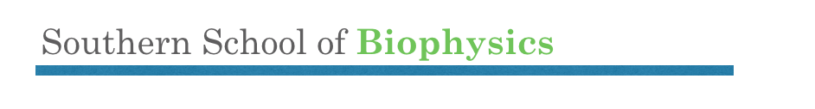
Valparaiso January 7-19, 2019

PRELIMINARY PROGRAM:
A twelve days Intensive hands-on international workshop on modern techniques to understand the biophysics of ion channels at the Centro Interdisciplinario de Neurociencia de la University of Valparaiso. A body of experts in the field will give morning lectures followed by laboratory work. Several lab activities will provide comprehensive coverage of the different tools being used today toward our understanding of ion channel gating and modulation at an atomic scale. Students will have the opportunity to rotate and learn different techniques or to learn one in depth.

Teachers:
Osvaldo Álvarez | Teresa Giráldez
Francisco Bezanilla | Miguel Holmgren
Andrea Bruggemann | Ramon Latorre
Andrés Chávez | Agustín Martínez
Chiayu Chiu | Alan Neely
Ana María Correa | Eduardo Perozo
Luis Cuello | Juan Carlos Sáez
José Antonio Gárate | Sergei I. Sukharev
Isaac García | Teresa Giráldez
Carlos González | Karen Castillo
Helmuth Sanchez

Sunday,. January 6th a Welcome reception starting at 7 pm

Summary Schedule

January 7th Teachers: Bezanilla, Alvarez, Holmgren
- General concepts of electronics.
- HH in action
- Actions potentials and ion currents in the squid giant axon
Lab: (1 activity) Squid axon voltage-clamp at Montemar: Action potential ion channels and Na/K ATPase

January 8-9th Teachers: González, Latorre, Neely.
- Biophysics of ion channels
- General concepts
- Principles of methods and techniques
- Structure and Function
Lab: (4 activities) Using two-electrode voltage clamp, cut-open oocyte voltage clamp and patch-clamp to record ionic and gating currents from voltage-dependent ion channels. Noise analysis on small, intermediate and large conductance channels Modulation of CaV by recombinant auxiliary subunit and other associated proteins. BK gating currents.

January 10-11th 5 Teachers: Bezanilla, Giráldez, González, Neely
- Voltage clamp fluorometry
- Patch clamp fluorometry
- Luminescence Resonance Energy Transfer
Lab: (3 activities) VCF, Patch fluorometry and LRET measurements

January 12th Teachers: Correa, Bruggemann, Latorre, Sukharev
- Reconstitution of channels in black lipid films
- Reconstitution in liposomes
- Patch-clamping of bacterial spheroplasts
Lab (3 activities) Reconstitution of channels in black lipid films, Reconstitution in liposomes, patch-clamping of bacterial spheroplasts

Sunday - January 13th – Field trip

January 14-15th Teachers: Perozo, Cuello, Garate
- Ion channel structure
- X-Ray
- Cryo-Microscopy
- Structural analysis
Lab (4 activities) Production and purification of recombinant ion channels. Functional study of purified channels on reconstituted bilayer. Theory and analysis of X-Ray/Crio EM data and modelling.
January 16th Teachers: Martinez, Sáez, García.
- Connexins: Hemichannels and Gap Junctions, General concepts.
- Physiological importance and role of Hemichannels in inflammatory processes and genetic diseases.
Lab (2 activities). Dye coupling and Fluorescence and Recovery After Photobleaching, patch-clamp, double whole-cell patch clamp.

January 17th Chiu, Chávez
- Neurons at work. Synaptic integration and neuronal excitability.

Lab: one-day demonstration of what you can do with a two-photon microscope. Optogenetics, patch-clamp in brain slices.

January 18th – Students presentations

Saturday - January 19th – Closing remarks and farewell party

